**Patent Draft**

Submitted by:

Group 8 CS-7A

Gauri Dargar

Aman Malik

Priyambada Pandey

**Title:** Profit-Lifter

**Field of Invention:** Retail market growth

**Background:** The reason to develop this model is to provide a combined solution to shop owners to increment their profit margins by combining customer segmentation and Forecasting sales.

**Objective:** The problems that we are highlighting are in the sector of sales, which includes any sector such as meals, retail, and other daily needs which states the human error which occurs while keeping a record of products and forecasting their sales.

Sometimes they end up buying products that do not give them valuable profit. The results of such practice lead to the wastage of unsold products and the capital the owner invests.

Taking into consideration the above-discussed problem our team has come up with a solution to represent an artificially intelligent solution which includes both forecasting sales and analyzing the customer's buying pattern which could prove fruitful to the confectionary shop holders recommending them to focus on buying products which have higher average sales to maximize their profit, plus it will also reduce wastage of products and helps in increasing the business.

**Flowcharts:**

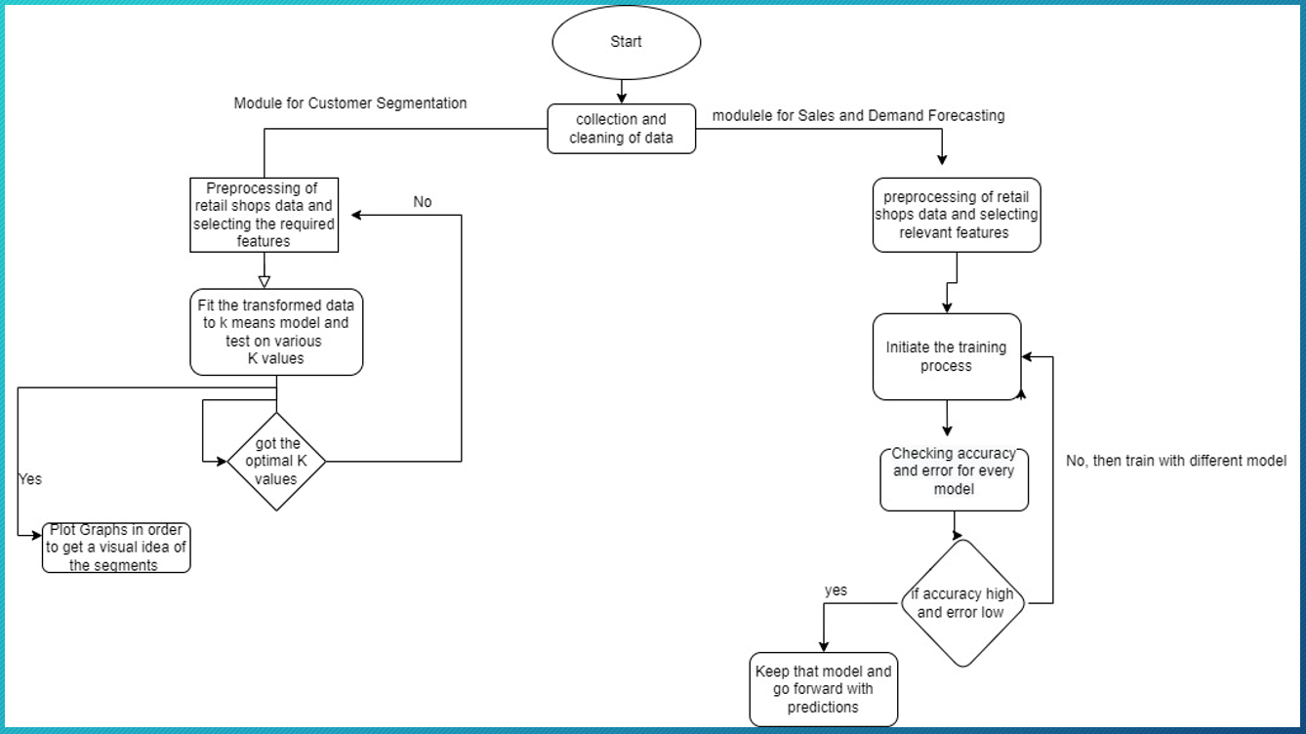

**Claims:** Taking into consideration the current situation of retail shops we claim that our solution for the retail shops comprises customer segmentation and sales forecasting in this manner we can look at two major parameters to improvise sales and retain customers. Having the right understanding of customers' choices and with correct analysis of sales, it could benefit retail shop owners to maximize their profits.

We are also looking for creating recommendations for the loyal customers of the shops which we have mentioned in the future works of the project.

**The technology used(Software):** The technology used in the project is Machine learning applied through the python programming language. We have used Regression algorithms such as Linear Regression, Random Forest Classification, and XGBoost and for Time series analysis the ARIMA model works well.

**Abstract:**

We all go to shops for buying products, and most of the shopkeepers stock a lot of products even if the sales of the product are not that high, which eventually doesn't give them valuable profit. The results of such practice lead to the wastage of unsold products and the capital the owner invests. This problem can be minimized by representing an artificially intelligent solution that includes both forecasting sales and analyzing the customer's buying pattern which could prove fruitful to the confectionary shop holders recommending them to focus on buying products that have higher average sales to maximize their profit, plus it will also reduce wastage of products. For this problem, we are using Python and machine learning for forecasting fruitful products. We are working on two modules one works on forecasting sales and the other one focus on customer segmentation. Our solution comprises notifying regular customers about whether the products they buy on daily basis are available or not (future work). Other modules will be added it to with time.

For customer segmentation, we will use K-means Clustering and for forecasting, we have trained the data on a few regression models such as Linear, random forest classifier, XGBoost, and LSTM networks. For time series forecasting we have implemented the ARIMA model.

**End users:** End Users will be the retail shop owners which would be provided with the facility of checking their customer segmentation and the forecasting of sales monthly or quarterly

For the other module (in future scope) the end user will be the loyal customer for that particular retail shop we will provide the recommendation for their every time products.

**Advantage:** As mentioned above in the claims our complement solution comprises customer analysis, predicting the sales, and recommendations this all will be done for small retail shops where every shop owner could get AI-generated information for their sales and that would help them to make more profits.

The shop owners could feed in their monthly or yearly sales and customer data to our model and could get results.

**Summary/Conclusion:** A concise literature review based on various machine learning techniques used in the predictive analysis is provided in this paper. It also provides a unique approach to designing an artificial intelligence-based prediction system. The designed system will mainly work as a recommendation system. It will use the concepts of machine learning and data mining technologies. Various machine learning models for predictive analysis have been tested and analyzed.XGBoost regression model gave the best performance in predicting future sales. we can predict future demand for products. This prediction system will be used to recommend products to small retail shops to keep in their inventory to help them maximize their profit.